NOTICE TO BIDDERS
Notice is hereby given that the Decatur County Board of Commissioners of the State of Indiana will receive sealed bids at the office of the Decatur County Auditor, Room 133, in the Decatur County Courthouse, 150 Courthouse Square Greensburg, Indiana on or before 2:00 p.m. EST Friday, February 13th, 2026, for the following:
“2026 Furnished and applied Seal Coat Type 3P except CCMG Project, 6P seal coat with Prime, and Fog Seal Projects “
in Decatur County, Indiana
Bids must be received, sealed, and filed in the office of the Decatur County Auditor, Room 133 no later than 1:45 p.m. EST Friday, February 13th, 2026 Decatur County Courthouse Greensburg Indiana,

“Notice to Bidder(s): Funds are not presently available for this contract. The County's obligation under this contract is contingent upon approval of the additional funding from, which payment for contract purposes can be made. The County reserves the right to cancel this solicitation, either before or after the closing date. In the event the County cancels this solicitation, the County has no obligation to reimburse an offeror for any costs.”

EACH BIDDER MUST SPECIFY ON THE OUTSIDE OF THE ENVELOPE:
“2026 Furnished and applied Seal Coat Type 3P except CCMG Project, 6P seal coat with Prime, and Fog Seal Projects”

Bids will be publicly opened and read aloud by representatives of the Decatur County Board of Commissioners in Room 106 (Large Meeting Room) at the Decatur County Courthouse 150 Courthouse Square Greensburg IN 47240 on Friday, February 13th, 2026, at 2:00 p.m. EST or shortly thereafter. Bids received after the advertised deadline will be returned unopened. Bids received by facsimile machine will not be accepted.

All bids must be accompanied by (1) a Certified Check, or a Bid Surety Bond payable to said Board of Decatur County Commissioners, in an amount equal to Five percent (5%) of the total amount of the bid, guaranteeing the successful bidder’s performance and fulfillment of the contract. Bids may be withdrawn prior to, but no bidder may withdraw their bid for a period of sixty (60) days after the day set for the opening of bids, without consent of the Owner or fails to execute a satisfactory contract within ten (10) days after notice of acceptance, the Owner may declare the Bid deposit forfeited as liquidated damages.

The Certified Checks, or Bonds of unsuccessful bidders will be returned upon award of the contract to the successful bidder.
All bidders MUST furnish the County with four (4) copies of bids.
Specifications and forms are on file in the DECATUR COUNTY HIGHWAY DEPARTMENT, or can be viewed at the Decatur County Auditor’s Office

Decatur County Highway Department  959 S CR 200W  Greensburg, Indiana 47240 | Decatur County Auditor’s Office  150 Courthouse Square Greensburg, Indiana 47240

Bid Documents: All bids shall be accompanied by (1) Bid Form included in the bidding documents (2) completed Form 96 (Ind. State Board of Accounts - Rev.) with required attachments (3) non-discrimination affidavit as required by the laws of the State of Indiana, and (4) Bid security, as described below (6) Other bidding documents as described in the instructions to bidders.

It is the intent of the Decatur County Commissioners to Award The ““2026 Furnished and applied Seal Coat Type 3P except CCMG Project, 6P seal coat with Prime , and Fog Seal Projects” Contract to 1 (sole) contractor submitting the lowest combined total cost of all Projects, One, Two, Three, (1,2,3,) and/or most responsive and responsible proposal as determined by the County. In determining the lowest and most responsive and responsible bidder, in addition to cost, the following factors shall also be considered: the number of days for mobilization of contract, the number of days for completion of services at all locations, ability to comply with all bid requirements, past record of performance with other clients including the quality of work, reliability, capability of staffing, and experience of Offeror to render prompt and satisfactory service of the volume called for under this contract. The Decatur County Board of Commissioners reserves the right to reject any and all bids and to waive, to the extent permitted by law, any of the terms, conditions or provisions contained in this Notice to Bidders, or any informality, irregularity, omission of any bid provided that such waiver shall, in the discretion of the Decatur County Board of Commissioners, be to the advantage of Decatur County.

Decatur County Board of Commissioners,

Brian Wenning
Jeremy Pasel
Gabriel Nobbe

INSTRUCTIONS TO BIDDERS

Owner: Decatur County by Board of County Commissioners
150 S Courthouse Sq.
Greensburg, IN 47240

Project/Work: “2026 Furnished and applied Seal Coat Type 3P except CCMG Project, 6P seal coat with Prime, and Fog Seal Projects”

Owner’s Representative: Tim Ortman, Highway Assistant Superintendent
959 S CR 200 W
Greensburg IN 47240
812-663-2682
tortman@decaturcounty.in.gov

SCOPE OF WORK

- PROJECT # 1 INDOT Type 3P Single Chip Seal over asphalt the total estimated area to receive a Type 3P seal coat with AE90S and SC 11 aggregate seal coat (Chip and seal) is approximately. 52 miles of roadway consisting of approx. 552,000 square yards at various locations throughout Decatur County. The scope of work for this project includes furnishing all labor, materials, equipment, fixtures and services required for the applying INDOT Type 3P Single Chip Seal over asphalt. All work is to be done in accordance with the plans, specifications, and contract documents.

- PROJECT # 2 Type 6P Seal Coat INDOT Section 404 over Prime Coat INDOT section 405 applied to compacted aggregate base on approx. 7 miles of roadway consisting of approx. 63,000 square yards at various locations throughout Decatur County. The scope of work for this project includes furnishing all labor, materials, equipment, fixtures and services required to construct a double-layer aggregate surface treatment to an existing aggregate surface by applying asphaltic emulsion (AE-PL) followed with two separate applications with the first being an AE-90S and 9 cover aggregate and the second of an AE-90S with 11SC graded aggregate surfacing material. The Contractor shall observe the condition of the gravel road prior to bidding to determine the work necessary to provide a proper base for double chip seal application and shall include the work necessary in the bid

- PROJECT # 3 Fog Seal over chip seal. on approx. 8 miles of existing chip seal roadway consisting of approx. 76,000 square yards at various locations throughout Decatur County. The scope of work for this project includes furnishing all labor, materials, equipment, fixtures and services required for the applying liquid asphalt emulsions

LOCATION
Various roads located in, Decatur County, Indiana, are detailed on a Itemized Sheet and shown on map as included in the Appendix.

DEFINITIONS (see Section 101 of the Standard Specifications for additional information)

The “Agreement” is the Agreement Between Owner and Contractor to be entered into by the Owner and the successful Bidder of the Project.

The “Bidding Documents” include the Notice to Bidders, Instructions to Bidders, Bid Proposal including Itemized Proposal, Signature Affidavit, Bid Bond, Non-Collusion Affidavit, Non- Discrimination Affidavit, Affidavit of Subcontractors Employed, E-Verify Affidavit, Agreement Between Owner and Contractor, Plans, Specifications, including any Addenda to such documents issued prior to the receipt of Bids. All definitions included in the Contract, Specifications or the other Contract Documents shall apply to the Bidding Documents.

The “Specifications” include the Indiana Department of Transportation 2024 Standard Specifications, including all Supplemental Specifications (all directions, provisions, and requirements pertaining to the performance of the Work), General Provisions, and Special Provisions. All references in the Specifications to the “Commissioner” and / or “Department” shall be interpreted to refer and mean the “Owner”. All references in the Specifications to the “Engineer” shall be interpreted to refer and mean the Owner or their authorized representative.

The “General Provisions” include the general requirements for the project.

The “Contract Documents” include the Bidding Documents, Agreement, Plans, Specifications, General Provisions and Special Provisions.

The “Addenda” are written or graphic instruments issued by owner or engineer prior to the execution of the Agreement which modify or interpret the Bidding or Contract Documents by additions, deletions, clarifications and corrections.

The “Engineer” is the Owner or their authorized representative.

A “Bid” is a completed and properly signed bid proposal and itemized proposal in which the bidder proposes to perform the work, or designated portion of the work, for the sum or sums stipulated therein and supported by information called for by the Bidding Documents.

An “Alternate Bid” is an amount stated in the bid to be added to or deducted from the amount of the bid if the corresponding change in the scope of the work or products or methods of execution of the work described in the bidding documents are accepted by the owner.

“Day” means calendar day, unless otherwise specifically defined.

A “Unit Price” is an amount stated in the Bid as a price per unit of measurement for products or services described in the bidding documents. Unit prices may be used to increase or decrease the contract sum.

SCOPE OF WORK

Bid Proposals are to provide for the construction and completion of the project in every detail of the work described. Bidder shall provide all materials, labor, tools, equipment, supplies, safety equipment, transportation and supervision necessary to perform, and shall perform, the work generally described, in a good and workmanlike manner and in accordance with the Contract Documents (as herein defined) as necessary to produce the results intended by the Contract Documents, including the protection of all property traversed or approached (all hereinafter called the “Work”).

COMPLETENESS OF SPECIFICATIONS AND PLANS

The physical make-up and content of the Plans and Specifications are intended to be complete for preparing and submitting of Bid Proposals. However, the Bidder shall verify to its own satisfaction that all materials issued are complete. Should the Bidder discover that a page or sheet is missing, the Bidder shall notify the Owners representative in writing. After bids have been submitted, no claims of ignorance of the requirements of bidding or of construction due to such missing or overlooked materials will be recognized.

The coordination of the Plans and Specifications shall be in accordance with Section 105.04 of the Standard Specifications. In the event of conflict or discrepancies between and among the Contract Documents, figure dimensions shall take precedence over scale measurements, large scale details shall take precedence over small scale plans or drawings, and plans or drawings of a later date shall take precedence over those of an earlier date. Any part of the Work shown on the Plans but not specifically mentioned in the Specifications, or vice versa, shall be considered as part of the Work as though included in both. Likewise, the Work to be undertaken by Contractor shall include all incidental work necessary as customarily done for the completion of the Project even though it may not be specifically described in the Specifications or Plans.

Any discrepancies found between the Plans and Specifications and site conditions or any inconsistencies or ambiguities in the Plans or Specifications shall be immediately reported to the Engineer in writing. Such corrections and interpretations as may be deemed necessary for fulfilling the intent of the Plans and Specifications will then be made. Reliance by the Bidder after the discovery of such discrepancies, inconsistencies or ambiguities shall be at the Bidder's risk.

Bidder’s attention is directed to special or unusual local conditions which may exist. For example, the character and location of existing structures above and underground may not be entirely or accurately represented in the Plans. Therefore, Bidder shall investigate all conditions and representations made in the Plans to its certainty prior to submitting its Bid Proposal. The information shown in the Plans is merely indicative of, or typical, of the nature of some of the existing structures the Bidder may expect to observe or encounter.

BIDDERS REPRESENTATIONS

The Bidding Documents are available for examination by the Bidder at the location(s) and time provided in the Notice to Bidders. The Bid Proposal will be furnished with each set of Plans and Specifications. By submitting a Bid, the Bidder represents that it (1) has fully examined the Bidding Documents, (2) has investigated the nature, locality, and site of the Work and the conditions and difficulties under which the Work is to be performed, and (3) submits its Bid on the basis of its own examination, investigation, and evaluation of all such matters and not in reliance upon any opinions or representations of the Owner or the Engineer.

The Bidder represents that its Bid is based upon the Work described in the Bidding Documents, including materials and equipment, without exception.

Submission of a Bid will be considered as conclusive evidence of the Bidder’s representations. No allowance shall be permitted to the successful Bidder by reason of any error or omission on the Bidder’s part.

EXAMINATION OF THE BIDDING DOCUMENTS

During the bidding period, should questions arise as to the intent, interpretation, correction of any ambiguity, inconsistency, error or meaning of any part of the Plans, Specifications, Addenda, or any other Bidding Document that may affect the Bidder, the Bidder shall submit a written Request for Clarification to the Owner. The Owner will make such clarification only by Addendum which shall be Emailed to each Bidder or may be picked up at the office of the Owner. Receipt of all Addenda shall be acknowledged with the Bid Proposal. No written Request for Clarification will be accepted by the Owner unless submitted on the Request for Clarification. All requests must be received no later than ten (10) days prior to letting. The Bidder shall not rely upon any interpretation, change or correction given by any other method.

Addenda issued as of the Bid Date shall be listed in the Bid Proposal in the space provided. Failure of the Bidder to receive any Addendum shall not relieve the Bidder from any obligations under its Bid, provided the Addendum was sent by email, facsimile, or by U.S. Mail to the address of the Bidder’s principal office or as other furnished by the Bidder.

BIDDING REQUIREMENTS

The Owner will issue Bidding Documents, including Plans, Specifications and Addenda to Bidders, and the same are also available for viewing at the locations listed in Notice to Bidders.

It is mandatory that the Bidder visit the site prior to submitting a Bid and thoroughly familiarize itself with existing site conditions and Work to be performed as indicated in the Bidding Documents, Plans, Specifications, and Addenda. Extra compensation or extension of time will not be allowed for failure to examine the site.

Sealed Bids for the Work will be received at the time, date and location stated in the Notice to Bidders. A Bid received after the Bid Date will be returned to the Bidder unopened.

All Bids must be prepared on the Bid Proposal (including Itemized Proposal) provided in the Bidding Documents.

All blank spaces on the Bid Proposal and Itemized Proposal must be fully filled in by typewriter or in ink. Any inter-lineation, alteration or erasure on the Bid Proposal and Bid Form must be initialed by the person who signed the Bid. The Bidder shall make no additional stipulations on the Bid Proposal or Bid Form and shall not qualify its Bid in any manner.

The Bidder's Itemized Proposal shall include unit prices, amounts and totals for each item listed. The Bid Proposal shall be fully executed, signed and notarized with notary seal attached.
Each copy of the Bid Proposal shall include the legal name of Bidder and shall be signed by the person or persons legally authorized to bind the Bidder. A Signature Affidavit is required with and as a part of the Bid if anyone other than the president of the corporation is signing the bid documents. A Bid Proposal and other documents submitted by an agent shall have a Signature Affidavit attached certifying the agent’s authority to legally bind the Bidder. All required bid documents must contain original handwritten signatures.

All copies of the Bid Proposal, the Bid Bond and any other documents required to be submitted with the Bid Proposal by statute, rules or these instructions shall be enclosed together in a single sealed envelope. Bid Proposals shall be rejected if all required documents are not in a single sealed envelope. The envelope shall be addressed to the Owner and shall be identified by the Project name, the Bidder’s name and address, Bid time and Bid date. If the Bid is sent by mail, the sealed envelope must be marked with the notation “BID ENCLOSED”. Oral, facsimile, telegraphic and electronic Bids will not be received by Owner.

Each bidder must file with the Bid Proposal a completely filled in General Form 96, as prescribed by the State Board of Accounts.

Each bidder must file with the Bid Proposal a Signature Affidavit, if applicable, signed by the same authorized person(s) who signed the Bidding Documents, notarized with seal affixed.

Each bidder must file with the Bid Proposal a completely filled in and executed Bid Bond or certified check as required by Ind. Code 36-1-12-4.5. The Bid Bond penal sum or certified check amount shall be five percent (5%) of the Bid Proposal including all additive alternatives.

Each bidder must file with the Bid Proposal a Non-Collusion Affidavit signed by the same authorized person(s) who signed the Bid, notarized with seal affixed.

Each bidder must file with the Bid Proposal a Non-Discrimination Affidavit signed by the same authorized person(s) who signed the Bid, notarized with seal affixed.

Each bidder must file with the Bid Proposal, the completed Contractor’s Affidavit of Subcontractors Employed which lists the subcontractors, whose subcontract amount will be $100,000.00 or more, with whom the Bidder proposes to perform work.

Each bidder must file with the Bid Proposal, an E-Verify Affidavit signed by the same authorized person(s) who signed the Bid, notarized with seal affixed.

Each bidder must file with the Bid Proposal a Drug Testing Policy Affidavit signed by the same authorized person(s) who signed the Bid, notarized with seal affixed.

A Bidder with proper identification may withdraw his Bid at any time prior to the scheduled time for receipt of the Bids; however, no Bid or Alternate Bid may be withdrawn without written consent of the Owner for a period of sixty (60) days after the Bid Date, or unless extended in accordance with Ind. Code 36-1-12-6. Bids received after the designated due time for any reason shall be rejected and returned unopened to the Bidder. The Owner reserves the right to accept or reject any Bid and to waive any irregularities in bidding.

The Owner reserves the right to request updated financial information or contractor experience as a basis for rejection of Bid or award of contract.

NOTICE OF AWARD AND AWARD PROCEDURE

Prior to execution of the Agreement, the Owner will issue to the successful Bidder a Notice of
Award stating that its Bid was the responsible and responsive bid and that the enclosed Agreement is submitted for execution without further negotiation. If the successful bidder finds it in accordance with the Bidding Documents, it is to be returned to the Owner by certified mail or in person within ten (10) calendar days after receipt for further execution and with the caution that a contract will not exist until it is signed by all signatories required. Failure to execute the proper Agreement and furnish the ancillary documents shall constitute reason for surrender of the Bid Bond or certified check.

At the time of returning the executed Agreement to the Owner, the successful Bidder shall furnish a completed and executed Performance Bond and Payment Bond to the Owner as part of the Agreement.

BIDS MAY BE REJECTED FOR THE FOLLOWING REASONS

If the Bidder’s Bid Proposal, Signature Affidavit, Bid Bond, Non-Collusion Affidavit, Non-Discrimination Affidavit, Contractor’s Affidavit of Subcontractors Employed, or E-Verify Affidavit are not signed and notarized as required by these Instructions to Bidders.

If the Bidder has submitted a Bid Proposal that does not conform in all material respects to the Plans, Specifications and Addenda.

If the Bidder’s Bid Proposal does not comply specifically with the Notice to Bidders and Instruction to Bidders.

If the Bidder has not complied with the applicable statutes, ordinances, resolutions or rules pertaining to the award of the Agreement.

If the Owner determines that the Bidder is not responsible based on the Bidder’s ability and capacity to perform the Work; the integrity, character and reputation of the Bidder; or the competence and experience of the Bidder.

If no Bid Proposals received are under or within the amount of funds that are available for the Project.

If the Bidder adds any provisions to his Bid Proposal reserving the right to accept or reject the award of the Agreement.

If the Bidder adds conditions or alternates not requested to his Bid Proposal (voluntary alternates).

If there are unauthorized additions or irregularities of any kind which tend to make the Bid Proposal incomplete, indefinite or ambiguous as to its meaning or amount.

If situations develop which make it impossible or not practical to proceed with the proposed work. If subsequent to the opening of Bid Proposals, facts exist which would disqualify the lowest Bidder.

If Bid Proposals are received after the designated due time as stated in the Notice to Bidders.

If all documents required to be submitted with Bid Proposal are not included in a single fully identified sealed envelope as required by the Notice to Bidder and Instructions to Bidders.
If all required Bid Proposals or alternate(s) amounts, or unit prices and equipment lists are not submitted with the Bid Proposals when specifically called for by Plans, Specifications and Addenda issued on this Project.

If sealed Bid Proposals are received in an unidentified envelope.
If the Bidder did not attend any mandatory pre-bid conference.

PERFORMANCE AND PAYMENT BONDS

Upon execution of the Agreement, Bidder is required to furnish to Owner a Performance Bond and Payment Bond covering its faithful performance and the payment of all obligations arising in relation to the Work. The Performance Bond and the Payment Bond shall each be in an amount equal to one hundred percent (100%) of the Contract Sum.

The Bonds shall be executed by a responsible surety licensed in the State of Indiana. The Bonds shall remain in effect for a period not less than one (1) year following the date of Substantial Completion or the Bidder’s warranty period, whichever is longer.

SUBMISSION OF LIST OF SUBCONTRACTORS AND SUPPLIERS

The Bidder shall submit a list of the Subcontractors or other persons or entities proposed for the principal portions of the Work.

The Bidder will be required to establish to the satisfaction of Owner the reliability and responsibility of each Subcontractor or other persons or entities proposed by the Bidder.

RETAINAGE

The Owner will retain an amount of each progress payment in accordance with the Agreement.

SPECIAL PROVISIONS AND SPECIFICATIONS
“2026 Furnished and applied Seal Coat Type 3P except CCMG Project, 6P seal coat with Prime , and Fog Seal Projects” ,
Decatur County, Indiana
SCOPE OF WORK:

1. PROJECT # 1 INDOT Type 3P Single Chip Seal over asphalt the total estimated area to receive a Type 3P seal coat with AE90S and SC 11 aggregate seal coat (Chip and seal) is approximately. 52 miles of roadway consisting of approx. 552,000 square yards at various locations throughout Decatur County. The scope of work for this project includes furnishing all labor, materials, equipment, fixtures and services required for the applying INDOT Type 3P Single Chip Seal over asphalt. All work is to be done in accordance with the plans, specifications, and contract documents.

2. PROJECT # 2 Type 6P Seal Coat over Prime Coat applied to compacted aggregate base on approx. 7 miles of roadway consisting of approx. 63,000 square yards at various locations throughout Decatur County. The scope of work for this project includes furnishing all labor, materials, equipment, fixtures and services required to construct a double-layer aggregate surface treatment to an existing aggregate surface by applying asphaltic emulsion (AE-PL) followed with two separate applications with the first being an AE-90S and 9 cover aggregate and the second of an AE-90S with 11SC graded aggregate surfacing material. The Contractor shall observe the condition of the gravel road prior to bidding to determine the work necessary to provide a proper base for double chip seal application and shall include the work necessary in the bid

3. PROJECT # 3 Fog Seal over chip seal. on approx. 8 miles of existing chip seal roadway consisting of approx. 76,000 square yards at various locations throughout Decatur County. The scope of work for this project includes furnishing all labor, materials, equipment, fixtures and services required for the applying liquid asphalt emulsions.

DESCRIPTION:
Work under this contract shall consist of the Contractor furnishing and applying liquid asphalt emulsions and cover aggregate seal as required on designated county roads.

LOCATION OF WORK The Work is in various locations throughout Decatur County. Specific locations will be shown on plans provided to the Contractor at preconstruction meeting. Notify the highway superintendent or their designee before delivering chips to ensure proper storage location.
TECHNICAL SPECIFICATIONS:
GOVERNING DOCUMENTS
The applicable sections of the following documents shall apply except as modified
elsewhere herein: the Technical Specifications, INDOT Standard Specifications, Decatur County Standards, Itemized Proposal, Map, and Contract.

Unless otherwise specified within the Contract Documents, whenever any specification, standard, reference material, manual or other similar document is incorporated by reference into any of the contract documents, it shall be deemed to be the latest edition of said item including any and all supplemental addendum, which was in effect on the date of the bid opening for this project

All out-of-state corporations must have a certificate of authority to do business in the State. Application forms may be obtained by contacting the Secretary of State, State of Indiana, Statehouse, Indianapolis, Indiana 46204.

QUESTIONS REGARDING THE PROJECT
All questions concerning this project shall be submitted in writing to, contact Tim Ortman, Decatur County Highway Assistant Superintendent at (812) 663-2682 or by email at tortman@decaturcounty.in.gov . prior 9:00 AM EST on Thursday February 12, 2026. Any required addendum will then be emailed to all bidding contractors by 12:00 PM (noon) EST February 12, 2026. The written response will be emailed to the addresses on the “Record of Plans” that is required to be filled out by anyone purchasing plans. No questions will be answered by telephone.

INDOT PREQUALIFIED
The Contractor shall be INDOT Prequalified, meeting and complying with all requirements per. Indiana Code 8-23-10 and is to submit evidence as part of bid.
EVALUATION &AWARD OF PROJECT
It is the intent of the Decatur County Commissioners to Award The : “2026 Furnished and applied Seal Coat Type 3P except CCMG Project, 6P seal coat with Prime , and Fog Seal Projects “ Contract to 1 (sole) contractor submitting the lowest combined total cost of all Projects, One, Two, Three, (1,2,3,) and/or most responsive and responsible proposal as determined by the County. In determining the lowest and most responsive and responsible bidder, in addition to cost, the following factors shall also be considered: the number of days for mobilization of contract, the number of days for completion of services at all locations, ability to comply with all bid requirements, past record of performance with other clients including the quality of work, reliability, capability of staffing, and experience of Offeror to render prompt and satisfactory service of the volume called for under this contract. The Decatur County Board of Commissioners reserves the right to reject any and all bids and to waive, to the extent permitted by law, any of the terms, conditions or provisions contained in this Notice to Bidders, or any informality, irregularity, omission of any bid provided that such waiver shall, in the discretion of the Decatur County Board of Commissioners, be to the advantage of Decatur County.

HOLIDAYS AND WHEN WORK IS NOT PERMITTED
The Contractor may not perform work on the following days unless requested and approved or permitted by the Highway Department or Owner:
• Saturdays and Sundays (unless otherwise approved by Owner’s Representative)
• Decatur County Highway Department Holiday Schedule

PRECONSTRUCTION MEETING
Prior to the start of any work for this project, a preconstruction meeting will be held between the Contractor, the Highway department, and the appropriate officials of Decatur County to discuss the proposed conduct of work, Subcontractors and suppliers may also be required to attend. The Contractor shall provide a written construction progress schedule including proposed construction work hours for the entire project to the County at this meeting also.
RIGHT OF ENTRY
The Contractor shall not encroach on private property for any reason without prior approval.

MOBILIZATION AND DEMOBILIZATION
Mobilization and Demobilization shall be in accordance with INDOT Section 110.

COMPLETION DATES
All work is to be done between May 1, 2026, and October 1,2026.
LIQUIDATED DAMAGES

The Contract Documents provide for the payment of liquidated damages in the event of
unexcused failure by the Contractor to complete the Work within the time required by the
Contract Documents. Such liquidated damages are to be assessed and recovered at the rate of
Two-thousand ($2000) Dollars per day for each Project that remains to be completed beyond the Contract Completion Date

The per diem rate(s) of liquidated damages established by the preceding sub-section have been determined and are intended as reasonable prospective estimate(s) of the type and amount of actual damages which the Owner may sustain in the event of such delay(s). Submission of a Bid shall constitute an unconditional acknowledgment and Agreement by the Bidder that such liquidated damages are fair and reasonable and do not and will not constitute a penalty, and that such liquidated damages may be assessed and recovered by the Owner as against the successful Bidder and its Surety in lieu of actual damages for delayed completion.

MATERIALS:
All aggregate and bituminous materials used for the project shall be produced from an approved source. The Contractor shall submit the names and addresses of the suppliers of these materials for the project to the Decatur County at the pre-construction conference. Prior to delivery, the Contractor shall submit to the Decatur County a copy of the certification for each material supplier.

LIQUID ASPHALT:
The asphalt material to be furnished and applied shall be specified by the highway superintendent or their designee The asphalt shall be heated as specified by the manufacturer. The Contractor shall have instrumentation and controls to monitor and alter the application rate and temperature of the liquid asphalt.

AGGREGATE:
Chip seal aggregate shall be durable, uniform in quality, and free from wood, bark, roots, and other deleterious materials.

EQUIPMENT:
The size and condition of all equipment shall be approved prior to construction. Should equipment be unsatisfactory for whatever cause, the Contractor shall remove and replace the equipment without delay or cost. The equipment shall conform to the following minimum requirements.

BITUMINOUS DISTRIBUTOR:
A minimum of two like distributors shall be used on this project. The distributors shall be self-powered and capable of providing a uniform application rate of emulsion varying from .05-1.00 gallons per square yard over a variable width up to 24 feet in a single pass. The asphalt distributor shall be capable of maintaining the asphalt binder at the specified temperature. The uniformity of the distributors shall not vary by more the two-hundredths gallons per square yard. The distributors shall be equipped with a variable power unit for the pump and full circulation spray bars, which are adjustable laterally and vertically. The nozzle angle and bar height shall be set to provide one hundred percent of double coverage in a single pass. The spray bar nozzles shall produce a uniform double lap application fan spray, and the shutoff shall be instantaneous, with no dripping. All nozzles shall be oriented at the same angle between 15 and 30 degrees using the wrench supplied by the distributor manufacturer. Each pressure distributor shall be capable of maintaining the specified application rate within ±0.015 gal/yd2 for each distributor load. Any areas that exceed 24’ in width where multiple passes will be required to complete the full width, the four inches adjacent to the second pass may be left with 50 percent coverage so that the next pass will complete the full application rate specified. Distributors shall be self-powered and include computerized application controls, a tachometer, pressure gauges, accurate volume devices, calibrated tank and a thermometer for measuring temperatures of the emulsion in the tank.

AGGREGATE SPREADER:
The aggregate spreader shall be self-propelled and supported by at least four tires on two axles capable of providing a uniform application rate of aggregate from five to 50 pounds per square yard over a variable width up to 24 feet in a single pass. The uniformity of this machine shall not vary by more than one pound per square yard. The aggregate spreader shall be equipped with the means of applying the cover coat material to the surface with computerized application controls so that the required amount of material will be deposited uniformly over the full width of the bituminous material. A computer rate-controlled aggregate spreader shall be required. To maintain constant stone application, a self-locking truck hitch will permit towing of aggregate trucks without stopping the chip spreader. It will be capable of maintaining positive engagement over irregular terrain.

ROLLERS:
A minimum of two self-propelled pneumatic tired rollers for the Chip Seal application. A pneumatic tire roller shall have a minimum rolling width of 5.5 ft The rubber-tired rollers shall have a gross load adjustable to apply 50-90 psi uniformly over the pavement The alignment of the axles shall be such that the rear- axle tires, when inflated to the proper pressure, can compact the voids untouched by the front-axle tires. Tire pressure shall be specified for the pneumatic tire rollers and shall not vary more than plus or minus 5.0 psi At no time shall the rollers travel more than 7 miles per hour.

TRUCKS:
For hauling aggregate shall be rear discharge equipped with a device to lock onto the hitch at the rear of the aggregate spreader to prevent spillage. Sufficient hauling vehicles shall be available to ensure continuous operations of the distributor and the aggregate spreader.

SWEEPERS:
Self-propelled four wheeled rotary mechanical brooms and or vacuum brooms capable of operating in both forward and reverse is recommended. Brooms should be checked to ensure they are in good condition and meet applicable environmental standards.
CONSTRUCTION NOISE
The Contractor shall be required to limit construction noise by maintaining his equipment in proper working order, thereby minimizing the effect of construction noise in the project areas.

EQUIPMENT CALIBRATION:
The contractor shall provide proof of calibration of the asphalt distributor and the aggregate spreader. The asphalt distributor shall be calibrated prior to the job. The asphalt application rate will be verified on a daily basis as calculated by dividing the total gallons of asphalt by the total area treated. The contractor shall submit the results of the calibration procedure to the County.

TEST STRIP:
The Contractor shall construct a continuous 500-foot-long test strip at the start of each roadway. The length of this may be adjusted slightly based on roadway characteristics and condition at the time of construction. The Contractor is to apply binder and stone at the plan rates unless directed by a representative of the county. The Contractor and county representative will review the test strip for streaking, ridging, bleeding, or other problems. The review will be onsite immediately after applying and rolling material, not the following day. Upon review the Contractor is to make any rate and/or quantity adjustments at the direction of the county representative. At this time the Contractor may proceed with the remainder of the work. The County may at any time request an additional test strip to modify the application rates.

WEATHER LIMITATIONS:
The Chip Seal shall not be applied when the pavement is moist, or when the weather is or may be detrimental. Detrimental weather is defined as rain showers, cool temperatures, moist pavements, threat of rain showers, or other environmental factors which could affect the performance of the Chip Seal construction. Relative humidity shall be less than 75%. No Chip Seal shall be applied if either the pavement or air temperature is below 60°F and falling but may be applied when both pavement and air temperatures are above 60°F and rising. Suspend chip sealing if the pavement surface temperature exceeds 140°F. The Chip Seal shall not be placed when freezing conditions are expected within 24 hours of application. No bituminous material shall be placed which cannot be cared for during daylight hours. Applications of asphalt will not be permitted when the wind velocity is excessive unless the spray bar is fully enclosed by a wind guard and satisfactory application can be attained.
Neither the County nor their designee will make determinations for ceasing operations due to forecasted rain. It shall be up to the Contractor to assess the risks associated with performing work with rain forecasted. If inclement weather occurs, the Owner or their designee shall have full discretion to reject work or require maintenance to completed areas that are determined to have been impacted by the weather.

TRAFFIC CONTROL:
MAINTENANCE OF TRAFFIC (MOT)
Traffic control devices shall be placed in accordance with the INDOT approved MUTCD.
Maintenance of traffic shall be the sole responsibility of the Contractor. Unless otherwise specified. Traffic should be discontinued on the project area being surface treated. The treated roadway shall not be used by the contractor or its agents until it has been established that the roadway will not be damaged or marred under the action of traffic Any damage to the applied chip seal shall be repaired by the Contractor at no additional cost to the agency. A recommended maximum speed of 20 mph should be maintained for a period of two hours. Contractor shall provide all flagging when flagging operations are required on a project, the Contractor shall provide qualified, suitably and equipped flagmen

All necessary precautions shall be taken for the protection of the work and safety of the public.
All labor, materials, equipment, and incidental work necessary to perform this work, shall be included in the lump sum price for “Maintaining Traffic” (MOT).

PROTECTION OF MOTOR VECHILES:
The Contractor shall be responsible for claims of damage to vehicles until the roadways and shoulders have been swept free of loose aggregate.

PRIOR TO CLOSING OR AFTER OPENING THE ROAD TO TRAFFIC
It will be necessary to close the road to traffic for the construction of the project. The Contractor shall notify Decatur County Highway Department, Decatur County Central Dispatch 911 center, and any affected schools.

Decatur County Highway Department (812) 663- 2682

Decatur County 911 Central Dispatch Center (812)222-4911

Decatur County Community Schools Central Office (812) 663-4595

Greensburg Community School Corporation (812) 663-4774

SURFACE PREPARATION
The Contractor shall be responsible for all measures required providing a thoroughly clean and dry pavement surface including vegetation removal and sweeping prior to the Chip Seal application. The Contractor shall observe the condition of the pavement prior to bidding to determine the work necessary to provide a clean, dry pavement for construction and shall include the work necessary in the bid. Immediately prior to applying the asphalt material, the existing roadway surface shall be thoroughly cleaned of all loose material, dust, salt, vegetation, and other objectionable material. Particular care shall be taken to thoroughly clean the outer pavement edges, ruts, dips, and intersections

PROTECTION OF UTILITIES Utility covers, manholes, grated inlets, curb inlets, survey monuments, concrete driveway approaches, sidewalks, and traffic device covers located in the roadway shall be protected from coverage and referenced for prompt location and cleaning following application. The Contractor shall be responsible for covering, locating, removing, and cleaning following application. The methods used to protect, reference, located, and clean shall be submitted by the Contractor and shall be subject to approval by the highway superintendent or their designee All such materials shall be removed and properly disposed of by the Contractor at the end of each workday.

APPLICATION:

Type 3P _APPLICATION RATES:
The asphalt material shall be applied in uniform and sufficient quantity to seal the pavement surface and provide bond to the cover aggregate. The following rates of application shall be used:

Application | Aggregate | Aggregate, lb/sy | Asphalt. gal/sy
Single | SC 11 | 20 | 0.40 +/- 0.03 AE90S
Apply the asphaltic material at the following: Rate of application: 0.40 +/- .03 gallons/SY
The aggregate shall be applied at the rate of 20 +/- 3 pounds per square yard. The Contractor shall take all precautions to minimize contamination of the aggregate.
Note: Rates of application shall be adjusted as necessary to obtain 70% embedment of the aggregate chip into the asphalt after the asphalt has cured and the road is open to traffic. Aggregate and asphalt shall be applied in a single pass. Making additional adjustments to the rate of application during the project may be needed.
Type 6P Double chip seal (11SC /9 )" APPLICATION RATES:
The asphalt material shall be applied in uniform and sufficient quantity to seal the pavement surface and provide bond to the cover aggregate. The following rates of application shall be used:

Application | Aggregate | Aggregate, lb/sy | Asphalt. gal/sy
First Course | 9 | 30 | 0.5+/- 0.03 AE90S

Application | Aggregate | Aggregate, lb/sy | Asphalt. gal/sy
Second Course | SC 11 | 20 | 0.45 +/- 0.03 AE90S

PRIME COAT APPLICATION RATES:
The asphalt material shall be applied in uniform and sufficient quantity to seal the pavement surface and provide bond to the cover aggregate. The following rates of application shall be used: AE-PL per INDOT Section 902. Application rate 0.25 +/- 0.03 gal. / sq. yd. or per the direction of Decatur County Highway Superintendent or their designee.
Prime Coat: Often required to penetrate the base and bind loose particles. Recommended curing time is 48 hours before applying the chip seal

FOG SEAL APPLICATION RATES:
The AE_F or approved equal material shall be applied in uniform and sufficient quantity to seal the, clean, and dry, pavement surface. The following rates of application shall be used:

- Application rate 0.10 +/- 0.02 gal. / sq. yd. or per the direction of Decatur County Highway Superintendent or their designee.

APPLICATION OF BITUMINOUS MATERIALS:
The application of the emulsion shall be performed by means of a pressure distributor in a manner to achieve a uniform and continuous spread over the asphalt surface. The temperature of the emulsion shall be a minimum of 160 F. The distributor shall be moving forward at proper application aped at the time the spray bar is opened. If at any time a nozzle becomes clogged or not spraying a proper pattern, the operation shall be immediately halted until repairs are made. Repairs shall be made immediately after deficiencies are noted and prior to the aggregate spreader at all times during construction. The width of the spread shall be no greater than the width of the aggregate spreader except where additional passes are required the emulsion shall be four inches beyond the aggregate spread at fifty percent application rate. At no time shall the emulsion be allowed to break, chill, setup, harden, or otherwise impair the aggregate retention before the aggregate has been properly applied and rolled. Distribution operations shall not proceed when it is evident the asphalt spread will not be covered with aggregate and rolled all in accordance with the prescribed schedule. At no time shall tires of the dump trucks or aggregate spreader come in contact with the fresh bituminous material.

APPLICATION OF COVER COAT AGGREGATE:
The aggregate shall be applied immediately following the emulsion application by the approved aggregate spreader. The Contractor, prior to start of work, shall calibrate the aggregate spreader to achieve the design application rate of the cover coat aggregate. Spreading shall be accomplished in such a manner that the tires of the trucks and aggregate spreader never contact the newly applied bituminous material. The width of the aggregate spreader shall be equal to the width of the emulsion spread, except where additional passes are required. Areas, which are deficient in aggregate, shall be covered immediately with additional material. The speed of the spreader shall be restricted to prevent the aggregates from rolling. Starting and stopping of the spreader shall be minimized. The edges of the aggregate application shall be sharply defined. Prior to rolling, correct deficiencies in application of cover aggregate in a manner satisfactory to the highway superintendent or their designee
Previously used aggregates from sweeping shall not be returned to the stockpile or the spreader for reuse.

ROLLING
Initial rolling shall begin immediately after the application of the cover coat aggregate. The first roller pass shall be completed within 2 minutes of aggregate application. The Contractor shall provide a minimum of two (2) pneumatic rollers and a completed rolling operation shall consist of three (3) complete coverages using pneumatic tired rollers. Rolling operations shall be completed within thirty (30) minutes after the cover aggregate is applied. Rollers shall be operated in unison, in a close interval, and if the width of spread allows, in a staggered formation. Rollers shall not be operated at a speed in excess of seven (7) miles per hour. The weight and tire pressures of the rollers shall be varied as to obtain the most satisfactory embedment of the cover material without undue crushing of the aggregate. Turning rollers on the freshly treated surface is prohibited. Rolling at night or when light conditions would create a traffic hazard will not be allowed. Should the rolling operation be delayed, the aggregate and emulsion spreading shall be halted until the operation regains proper sequencing and timing.

SWEEPING:
The contractor will be responsible for surplus aggregate left on the road surface where excess stone has been applied to the top layer. All extra stone from malfunctions and spills shall be removed by the contractor. Sweeping shall be done after chip seal has properly cured, and care will be taken not to dislodge imbedded aggregate or damage the surface. Any excess aggregate swept by the Contractor will be the responsibility of the Contractor for disposal. Disposal of excess material swept shall be included in the square yard price.

FOG SEAL CONSTRUCTION
To be effective, fog seals need to break quickly (revert to solid asphalt) and cure completely (lose water to form a cohesive film). This should be at a rate that allows traffic to be accommodated without the binder being picked up the vehicle tires. To achieve this behavior, the film forming properties of the binder must be adequate (i.e., the binder must be able to coalesce into a continuous film prior to allowing traffic on the new seal). Asphalt films do not form well at low temperatures in the absence of low viscosity diluents. Thus, warm conditions with little to no chance of rain are necessary to ensure successful applications. Ideal conditions are warm to hot temperatures with low humidity and a slight breeze.

If unexpected rain occurs, prior to the emulsion breaking, the emulsion may wash out of the pores of the pavement and break on the surface of the pavement creating a slippery surface.
Fog seal application shall take place only after the Contractor has notified the project adjacent residents and traveling public of said operation. The County shall be given notice to provide the public of the application of the fog seal. The Contractor should consider all aspects of his operations, such as weather limitations, work hours, public notification and equipment availability.

Traffic control is required to protect the integrity of the application and protect traffic from tracking the oil. The curing time for the fog seal material will vary depending on the pavement surface conditions and the weather conditions at the time of application. Under ideal conditions, including increasing air and surface temperatures, it is suggested that traffic be kept off the fog seal material for at least 2 (two) hours. Hours for Fog Seal application shall be 9:00am to no later than 3:00pm, unless approved by highway superintendent or their designee. Contractor is required to coordinate all access routes with adjacent businesses and homes.

PRIME COAT CONSTRUCTION
Description shall consist of a single application of asphalt material applied to the completed and approved subgrade Bidder shall apply material after Decatur County Highway Department has suitably prepared road surface by grading to remove potholes and shaped the road to drain. 24-hour advance notice to the Jefferson County Highway Department is required prior to application.

Construction Requirements
The surfaces of all structures shall be protected by some satisfactory method to prevent their being disfigured by the application of asphalt material
- Cleaning. If needed, the surface to be treated with prime shall be cleaned of dirt, and loose or foreign material by sweeping with mechanical brooms immediately preceding the application of the prime coat. Care shall be taken to clean but not loosen or dislodge the embedded aggregate in base courses. Dirt, or other material that do not form an integral part of the surface to be treated shall be removed. When directed, the surface shall be sprinkled with water and given an additional sweeping.The cleaning operations shall be carried only far enough in advance of the application of the asphalt material to ensure the surface being properly prepared at the time of application.
- Application of Prime Coat. After the surface to be treated has been prepared as outlined above, the asphalt material for the prime coat shall be sprayed uniformly over the surface by means of an approved mechanical pressure distributor at the rate of application indicated on the plans, or as directed. Surplus asphalt material collected in surface depressions shall be removed. Following the application of the prime coat, the road will be closed to traffic, if practicable, for a period of time sufficient to allow the proper curing of asphalt coating. Prime coat shall be allowed to cure a minimum of 3 days before any successive application of asphalt material. However, the minimum three day curing time may be waived when, in the opinion of the highway superintendent or their designee, the prime has sufficiently cured to allow placement of successive courses . No material for a succeeding course shall be placed on a primed base course until the prime coat has cured sufficiently to prevent damage by hauling operations. When shown on the plans or directed by the highway superintendent or their designee, the prime coat shall be applied in half widths in order to allow free passage of public traffic at all times. Prime coat shall not be applied when the air temperature is below 45° F (7° C), nor shall it be applied to a surface having excess moisture, nor when general weather conditions, in the opinion of the highway superintendent or their designee, are not suitable. Special precautions shall be observed to ensure a uniform distribution of the asphalt material. The distributor shall be so adjusted and operated as to distribute evenly the material being applied. Deposits of asphalt material upon the road surface in excess of the quantity specified, caused by stopping or starting the distributor, by overflow, leakage, or otherwise, shall be removed. The asphalt material shall be applied at the temperature specified by the manufacture . The Contractor shall provide the necessary facilities for determining the temperature of the asphalt material in the heating equipment and in the distributor, for determining the rate of application, and for securing uniformity of distribution at longitudinal and transverse joints. If the primed surface becomes damaged, such areas shall be cleaned or patched and re-treated at no cost to the County
QUALITY CONTROL:

The County reserves the right to cease operations at any time.

The Contractor is responsible for quality control (QC) of the materials and workmanship and shall submit a QC plan s for verifying the quality of the materials and workmanship. The Contractor’s QC plan shall include but is not limited to sampling, testing, inspection, monitoring, documentation, and corrective action procedures during transport, stockpiling and placement operations. All QC test results shall be submitted to Decatur County as required or at the end of the contract. A material certification shall be submitted from each supplier for each batch of material delivered to the project, including test results. The QC records shall be available to the Agency at all times and shall be retained by the contractor for the life of the contract. This work shall be the sole responsibility of the Contractor and will not be paid for separately but included in the cost of other items of the contract.
COMPLIANCE WITH SPECIFICATIONS
The Contractor shall attest in writing to Decatur County that the chip seal has been constructed in accordance with and meets the requirements of the specifications at the conclusion of the project.

MEASUREMENT AND PAYMENT:
The quantities stated in the bid will not be used in establishing final payment due the successful Contractor.
Payment for the accepted quantity of the Seal Coat at the Contract bid unit price of measure is compensation in full for all costs of furnishing and applying the material as specified. Payment shall be made in accordance with the schedule set forth below at the Contract bid price for the specified unit of measure.

Payment will be made under:
Project # 1
- Pay Item Pay Unit Symbol
Seal Coat, __3 P ................................................... SYS

Project # 2
- Pay Item Pay Unit Symbol
Seal Coat, __6 P ................................................... SYS

- Pay Item Pay Unit Symbol
Prime Coat ............................................................ SYS

Project # 3
- Pay Item Pay Unit Symbol
Fog Seal .................................................................. SYS

Such payment is full compensation for furnishing all materials, equipment, labor, and incidentals to complete the work as specified. Contractor to provide tickets and amounts with dates as applied on a daily basis per segment of each road. Final payment to be based upon actual quantities as applied. Payment shall be full compensation for the Seal Coat work completed in accordance with the above specifications.
Invoices shall be submitted to the Decatur County Highway Dept.to be processed via the normal claims schedule of the county. A claims schedule can be provided upon request.

APPENDIX
The denoted items below will be found on pages following this page:

Map showing 2026 Furnished and applied Project # 1 Type 3P
Itemized List of 2026 Furnished and applied Project # 1 Type 3P

Map showing 2026 Furnished and applied Project # 2 Type 6P with Prime
Itemized List of 2026 Furnished and applied Project # 2 Type 6P with Prime

Map showing 2026 Furnished and applied Project # 3 Type Fog Seal
Itemized List of 2026 Furnished and applied Project # 3 Type Fog Seal

Bid Tabulation Sheet

END OF INSTRUCTIONS TO BIDDERS

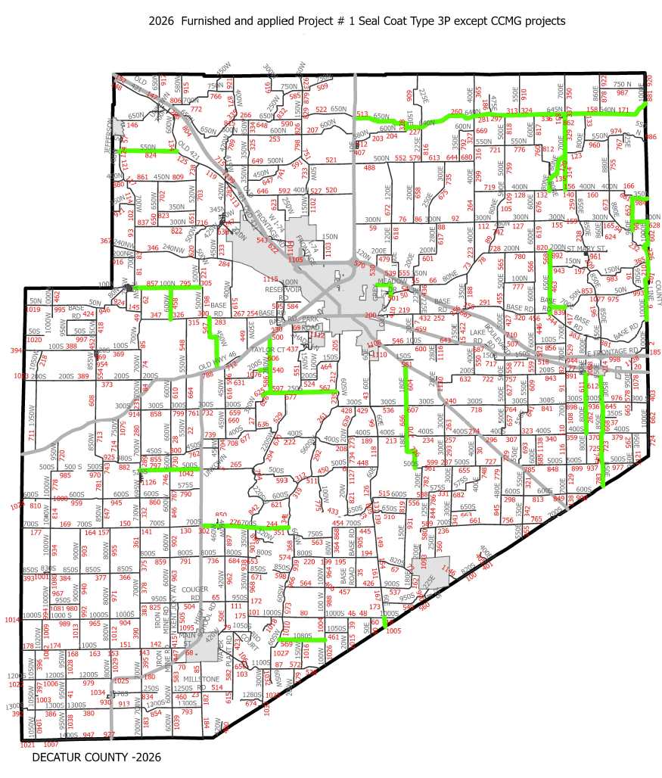

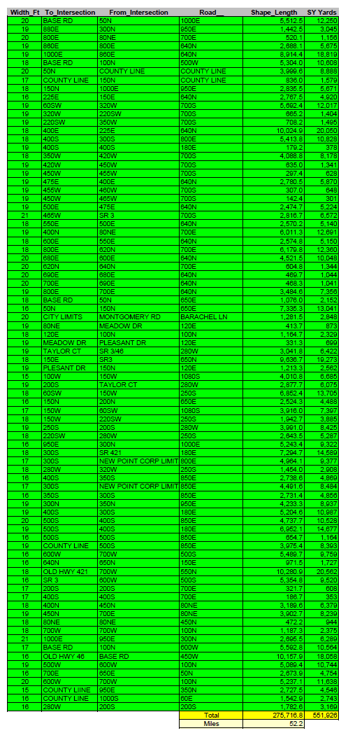
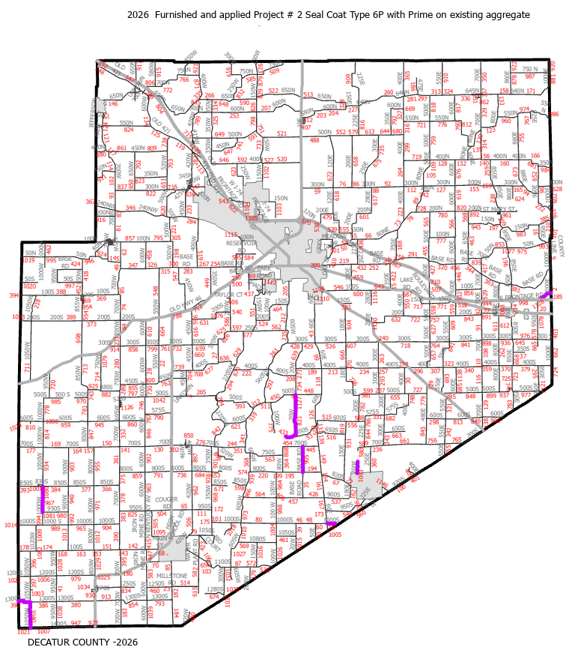
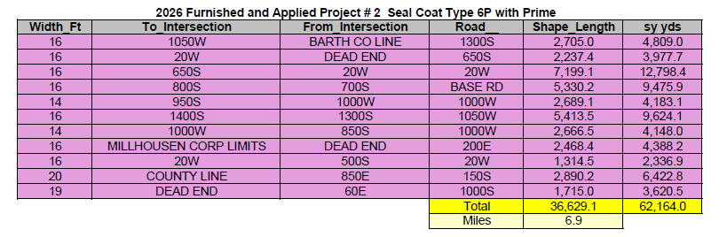
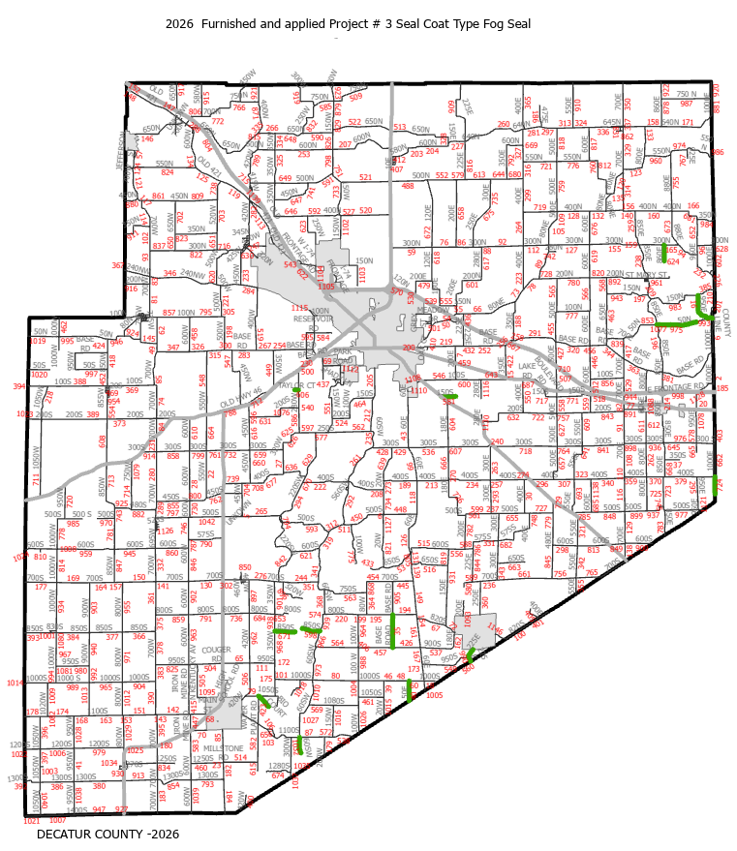
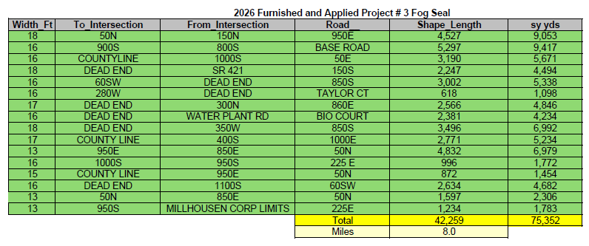

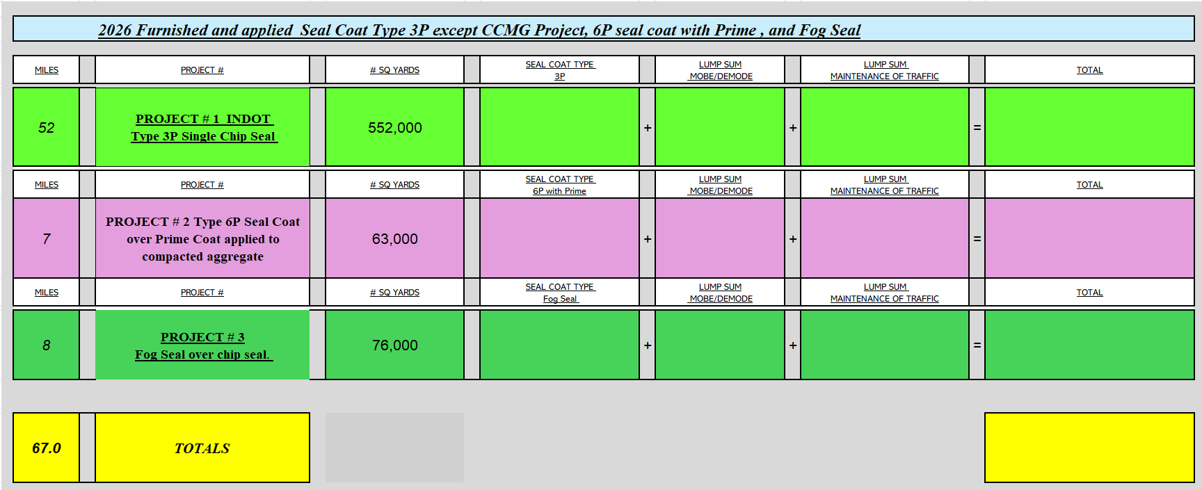

BID PROPOSAL / SIGNATURE AFFIDAVIT

To the Board of County Commissioners of Decatur County, of the State of Indiana, hereinafter referred to as the Owner:
“2026 Furnished and applied Seal Coat Type 3P except CCMG Project, 6P seal coat with Prime , and Fog Seal Projects”
DECATUR COUNTY, INDIANA
Pursuant to the legal notice that sealed bids for the above referenced project would be received by the Board of County Commissioners of Decatur County, Indiana, the undersigned Bidder:
- Acknowledges receipt of:
  - Bidding Documents, Plans, Specifications including the 2024 (or most current) Indiana Department of Transportation Standard Specifications, Supplemental Specifications, General Provisions, Special Provisions and Agreement Between Owner and Contractor
(the “Agreement”) provided to the Bidder dated____________________ | 2025.
  - Addend
No._____, dated_________________ No. _____ dated_____________________
No._____, dated_________________ No. _____ dated_____________________
No._____, dated_________________ No. _____ dated_____________________
No._____, dated_________________ No. _____ dated____________________.

- Has examined the site and all Bidding Documents, including the Agreement,
Specifications and Plans. Bidder shall be responsible for performing all Work specifically required by all parts of the Bidding Documents, including all Plans and Specifications for the entire Project even though such Work may be included as related requirements specified in other sections.
- Agrees to:
  - Hold this Bid Proposal open for sixty (60) calendar days after bid opening date.
  - Furnish a Bid Bond or certified check with this Bid Proposal for an amount specified in the Notice to Bidders and Instructions to Bidders.
  - If alternative bids apply, submit a Bid Proposal for each in accordance with the Instruction to Bidders.
  - Accept the provisions of the Instructions to Bidders regarding disposition of bid security.
  - Enter into and execute the Agreement with Owner, when awarded on the basis of this Bid Proposal without negotiation, and in connection therewith to:
    - Furnish a Performance Bond and Payment Bond and insurance in accordance with the Bidding Documents.
    - Accomplish the Work in accordance with the Contract Documents and Bidding Documents.
    - Complete the Work within the specified Contract Time.
- NOTICE OF AWARD: The Bidder agrees to execute the Contract provided by the Owner in the Bidding Documents when the Owner forwards the Notice of Award to the Bidder. Bidder agrees to acknowledge receipt of the Notice of Award and return the acknowledgement copy to Owner.
- NOTICE TO PROCEED: The Bidder agrees to commence the Work under the Contract on or before the date to be specified in the Notice to Proceed. Bidder agrees to acknowledge receipt of the Notice to Proceed and return the acknowledgement copy to the Owner.
- CONTRACT TIME: The Bidder shall complete the Work in accordance with the durations indicated in the Agreement. All work shall be completed and ready for acceptance within ninety (90) calendar days after the date specified in the Notice to Proceed for commencing Work.
- NON-COLLUSION: By submission of this Bid Proposal, each Bidder certifies, and in the case of a joint bid, each party thereto certifies as to its own organization, that the Bid Proposal has been arrived at independently, without consultation, communication or agreement as to any matter related to the Bid Proposal with any other Bidder or with any competitor.
- ASSIGNMENT OF CONTRACTS: Owner will not assign the Work in the Agreement to another Contractor nor assign the Work of another contractor to the Agreement.
- BASE BID: Bidder agrees to perform all work shown or specified in the Bidding Documents and Contract Documents, including the Plans and Specifications, for the unit prices given and calculated on the attached Itemized Proposal.
- REPRESENTATIONS AND CERTIFICATIONS: The Bidder by the execution of this Bid Proposal makes the following representations and certifications as a part of his Bid Proposal. In the case of a joint venture bid, each party represents and certifies each organization.
  - SURETY. Bidder has notified a surety company that it is submitting a Bid Proposal for Work to be performed on the Project. The surety company has agreed to issue a Performance Bond and Payment Bond for its Work on the form provided by Owner if this Bid Proposal is accepted and the Owner awards the Agreement to Bidder.
  - AFFIDAVIT OF DRUG TESTING POLICY. Bidder has properly executed the Affidavit of Drug Testing Policy as provided in the Bidding Documents and included the Affidavit as part of its Bid Proposal as submitted to the Owner.
  - AFFIDAVIT OF NON-DISCRIMINATION. Bidder has properly executed the Affidavit of Non-Discrimination as provided in the Bid Documents and included the Affidavit as part of its Bid Proposal as submitted to the Owner.
  - CONTRACTOR’S AFFIDAVIT OF SUBCONTRACTORS EMPLOYED. Contractor has properly executed the Contractor’s Affidavit of Subcontractor’s Employed as provided in the Bidding Documents and included the Affidavit as part of its Bid Proposal as submitted to the Owner.
  - E-VERIFY AFFIDAVIT. Bidder has properly executed the E-Verify Affidavit as provided in the Bid Documents and included the Affidavit as part of its Bid Proposal as submitted to the Owner.
- Pursuant to Ind. Code § 22-9-1-10 and 5-16-6, the Bidder and its subcontractors, if any, shall not discriminate against any employee or applicant for employment, to be employed in the performance of this Agreement, with respect to his hire, tenure, terms, conditions or privileges or employment or any matter directly related to employment, because of his race, color, religion, sex, disability, national origin or ancestry. Breach of this covenant may be regarded as a material breach of the Agreement

Principal:
By:
(
Business Name
)
(Signature)

(Printed)

(Title)
STATE OF INDIANA ) SS:
COUNTY OF )
Before me, the undersigned notary public, on this day of , 2026,
personally appeared as principal and being duly sworn, acknowledged the execution of the above Bid Proposal / Signature A

(Notary Public - Signature)
SEAL
(Notary Public - Printed)
My Commission Expires: .
Residing inCounty.
Surety:
(
Business Name
)
By:
(
Signature
)
(
Printed
)

(Title)

BID BOND
KNOW ALL BY THESE PRESENTS, that the undersigned:
Name of Contractor: _______________________________________________________________
Address of Contractor: _______________________________________________________________
Hereinafter called the Principal, and
Name of Surety: _______________________________________________________________
Address of Surety: _______________________________________________________________
Hereinafter called the Surety, are held and firmly bound unto
Name of Owner:
Address of Owner:
Hereinafter called the Obligee, in the penal sum of 10% of the amount of the Principal’s Bid, for the payment of which sum, well and truly to be made, the Principal and the Surety, bind themselves, their heirs, executors, administrators, successors and assigns, jointly and severally, firmly by these present.
Signed, this day of _________________, 2026. The Condition of the above obligation is such that whereas the Principal has submitted to the Owner a certain Bid Proposal, attached hereto and hereby made a part hereof to enter into the Agreement in writing, for the construction and completion of the project in accordance with the Plans and Specifications.
NOW, THEREFORE,
- If said Bid Proposal shall be rejected, or
- If said Bid Proposal shall be accepted and the Principal shall execute and deliver the Agreement in the form attached hereto (properly completed in accordance with said Bid Proposal) and shall furnish a Performance Bond for faithful performance of the Agreement, and a Payment Bond for the payment of all persons performing labor furnishing materials in connection therewith, and shall in all other respects perform the Agreement created by the acceptance of the Bid Proposal, then this obligation shall be void, otherwise the Bid Bond shall remain in force and effect; it being expressly understood and agreed that the liability of the Surety for any and all claims hereunder shall, in no event, exceed the penal amount of this obligation as herein stated. This Bid Bond shall adhere to the requirements of Ind. Code § 36-1-12-4.5.
The Surety, for value received, hereby stipulates and agrees that the obligations of the Surety and its Bid Bond shall be in no way impaired or affected by any extension of the time within which the Owner may accept such Bid Proposal; and said Surety does hereby waive notice of any such extension IN WITNESS WHEREOF, the Principal and the Surety have set their respective hands and seals, and as representatives of their respective entities have caused their appropriate seals to be affixed and signed by their proper officers, the day and year first set forth above.
Principal:
By:
(
Business Name
)
(Signature)

(Printed)

(Title)
STATE OF INDIANA )) SS:
COUNTY OF )
Before me, the undersigned notary public, on this day of , 2026,
personally appeared as principal and being duly sworn, acknowledged the execution of the above Bid Bond.

(Notary Public - Signature)
SEAL
(Notary Public - Printed)
My Commission Expires: .
Residing inCounty.
Surety:
(
Business Name
)
By:
(
Signature
)
(
Printed
)

(Title)

NON-DISCRIMINATION AFFIDAVIT
The undersigned, having executed the attached bid or bids for and on behalf of himself, his firm or corporation, being first duly sworn says:
In the performance of work under this contract, it is agreed that Contractor, any of its subcontractors, or any person acting on their behalf shall not, in any manner, discriminate against or intimidate any employee or job applicant with respect to his hire, tenure, terms, conditions or privileges of employment, or any matter directly or indirectly related to employment, because of his race, religion, color, sex, disability, national origin or ancestry or discriminate by reason of such factors against any citizen of the State of Indiana who is qualified and available to perform the work.
It is further agreed that a penalty may be deducted from the contract in the sum of five ($5.00) for each person for each calendar day during which such person was discriminated against or intimidated in violation of this provision. If a second or subsequent violation occurs, this contract may be terminated, and all monies due or become due hereunder may be forfeited. It is further agreed that a breach of this covenant may be considered a material breach of this contract.

OATH AND AFFIRMATION
I affirm under the penalties for perjury that the foregoing facts and information are true and correct to the best of my knowledge and belief.
Dated at thisday of , 2026.

(Name of Organization)
812-663-2682By:

(Title of Person Signing)

CONTRACTOR’S AFFIDAVIT OF SUBCONTRACTORS EMPLOYED
The following sub-contractors will perform work in Decatur County in fulfilling the Agreement with the Owner.
Name Trade Amount
1.
2.
3.
4.
5.
6.
7.
8.
9.
10.
(
Business Name
)
By:
(
Signature
)
(
Printed
)
(
Title
)

AFFIDAVIT OF EMPLOYEE DRUG TESTING PROGRAM
In Accordance with Indiana Code 4-13-18-6. Employee Drug Testing Program Requirements

We hereby certify that we have in place or will implement during the entire term of the contract a Mandatory Drug Testing Program for our employees on the jobsite, including subcontractors, that complies with this regulation:

(
Business Name
)
By:
(
Signature
)
(
Printed
)
(
Title
)

E-Verify Affidavit
“The CONTRACTOR affirms under the penalties of perjury that he/she/it does not knowingly employ an unauthorized alien.
The CONTRACTOR shall enroll in and verify the work eligibility status of all his/her/its newly hired employees through the E-Verify program as defined in IC 22-5-1.7-3. The CONTRACTOR is not required to participate should the E-Verify program cease to exist. Additionally, the CONTRACTOR is not required to participate if the CONTRACTOR is self-employed and does not employ any employees.
The CONTRACTOR shall not knowingly employ or contract with an unauthorized alien. The CONTRACTOR shall not retain an employee or contract with a person that the CONTRACTOR subsequently learns is an unauthorized alien.
The CONTRACTOR shall require his/her/its subcontractors, who perform work under this contract, to certify to the CONTRACTOR that the subcontractor does not knowingly employ or contract with an unauthorized alien and that the subcontractor has enrolled and is participating in the E-Verify program. The CONTRACTOR agrees to maintain this certification throughout the duration of the term of a contract with a subcontractor.
The OWNER may terminate the Contract for default if the CONTRACTOR fails to cure a breach of this provision no later than thirty (30) days after being notified by the OWNER.”
CONTRACTOR
<<
>>
)
Firm Name
(
)
Signature
(
)
Printed
(
(Title)

REQUEST FOR CLARIFICATION
Contractor:
RFC #
Date:
Project Title: _
Reference Drawing No.:
Specification Section:
Phone #: Fax #:
Clarification Request:

Request response by:
Note: All responses will be made in writing and distributed to all bidders.
(
Business Name
)
By:
(
Signature
)
(
Printed
)
(
Title
)

